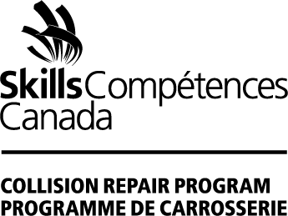
SKILLS CANADA COLLISION REPAIR PROGRAM: 2022 Sponsorship
The Skills Canada Collision Repair Program promotes careers in the Collision Repair Industry to students, parents, and teachers by increasing visibility and awareness of career opportunities at Skills Canada competitions across Canada. After a challenging 2021, we are expected to return to in-person Skills Competitions in 2022 and we can’t wait! We look forward to your involvement as an industry sponsor and hope you will join us onsite to be a part of the excitement.
Thank you for your continued support of the Skills Canada Collision Repair Program in 2022!
Company Name
Mailing Address
City/Province/Postal Code
Contact Name
Contact email
Contact phone number
Contact Signature
Date

Indicate Sponsorship Amount:
Gold Sponsorship | $7500
Silver Sponsorship | $5000
Bronze Sponsorship | $2500

Cheque Enclosed
Visa
Master Card
Send Invoice
Preferred invoice date

Credit Card #
Expiry Date
3-digit code
Signature

Please return this form to: Skills Competences Canada
Mail: 294 Albert Street, Suite # 201, Ottawa, Ontario K1P 6E6 Fax: 613-691-1404 Email: leannej@skillscanada.com
Questions? Contact Leanne Jefferies, Director, Skills Canada Collision Repair Program 905-628-2041

BENEFITS of SPONSORSHIP:
- Logo recognition on Skills Canada website
- Recognition and participation at Skills Canada competitions and events across Canada
- Opportunity to attend and sponsorship of the Skills Canada Automotive Technology Summit
- Logo recognition on Skill Canada Collision Repair Program ads (Gold)
- Visibility and recognition on Skills Canada social media channels

